Music Recommendation System Based on Users Facial Emotion

We have designed this as a web based application where user will be connected to Webcam and then user can take his snapshot and then click ‘Detect Emotion’ button to allow application to detect emotion from his face image and then display list of songs based on predicted emotion and then user can select and play desired emotion.

SCREEN SHOTS

To run project double click on ‘run.bat’ file to start python web server and get below screen

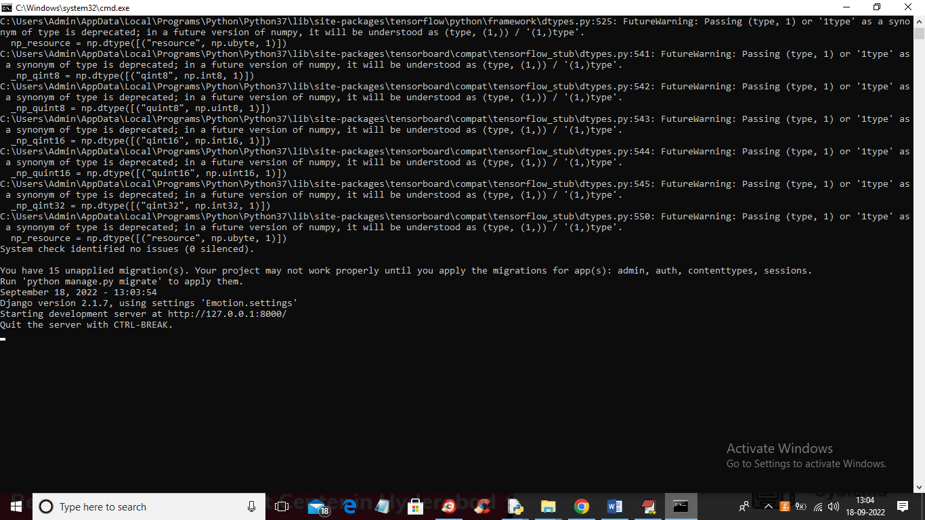

In above screen python Web Server started and now open browser and then enter URL as <http://127.0.0.1:8000/index.html> and press enter key to get below page

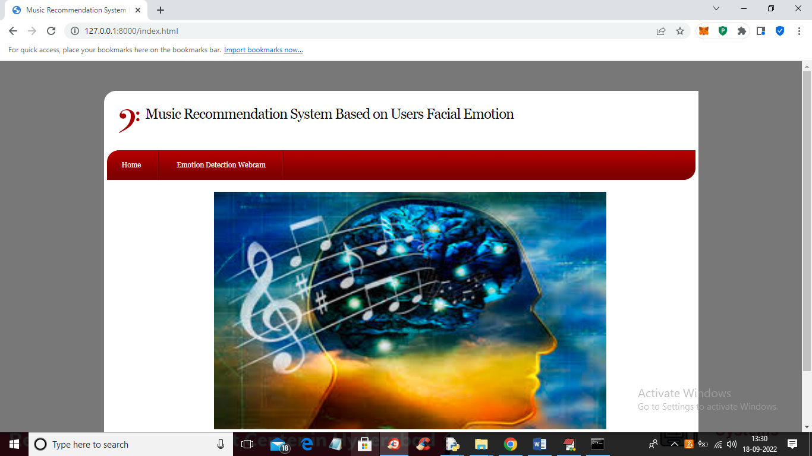

In above screen click on ‘Emotion Detection Webcam’ link to get below Webcam page

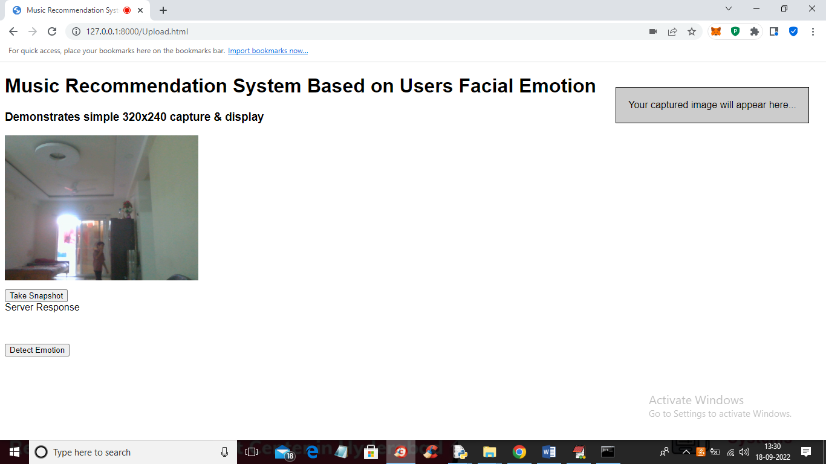

In above Webcam page show your face and then click on ‘Take Snapshot’ button to capture face image like below screen

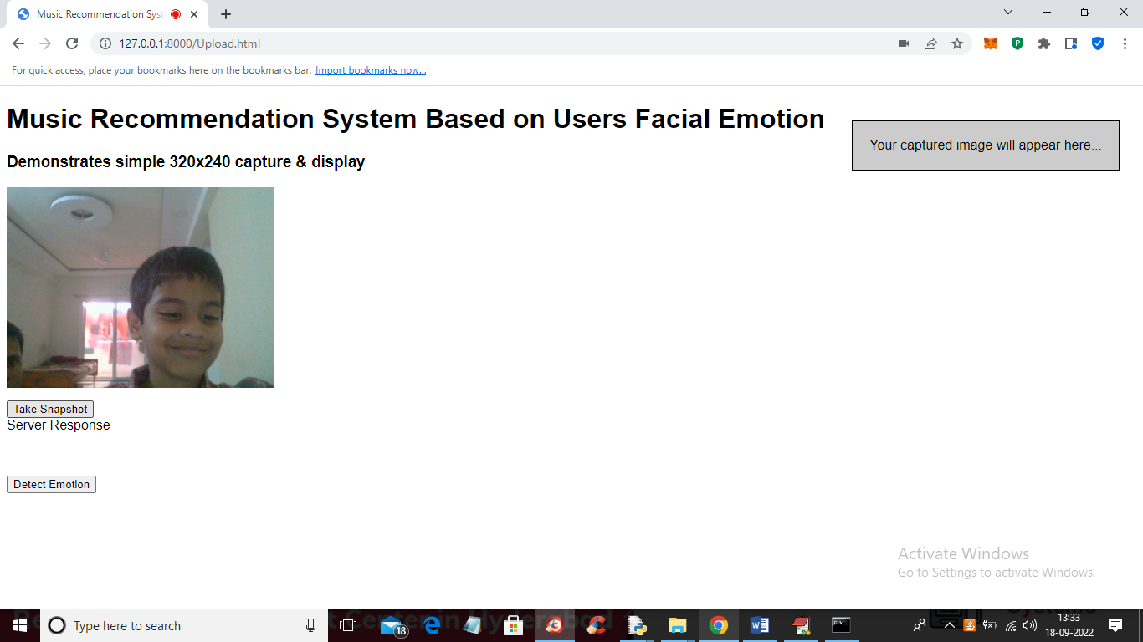

In above screen showing face in webcam and now click on ‘Take Snapshot’ button to capture face like below screen

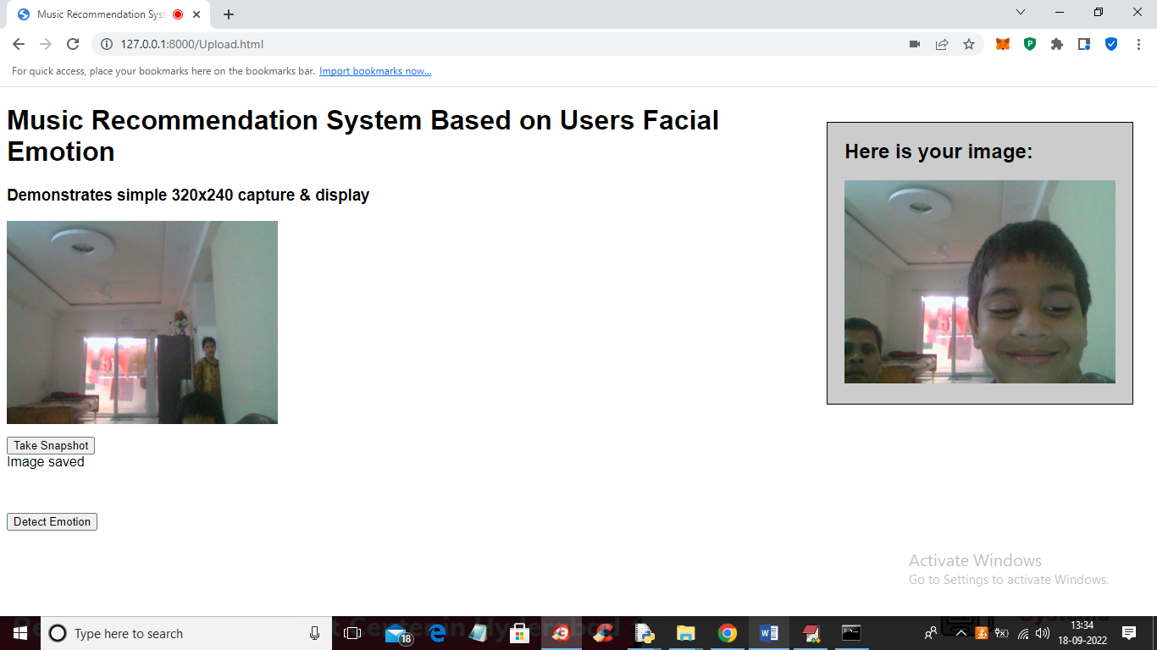

In above screen face is captured and now click on ‘Detect Emotion’ button to predict emotion and get below song list

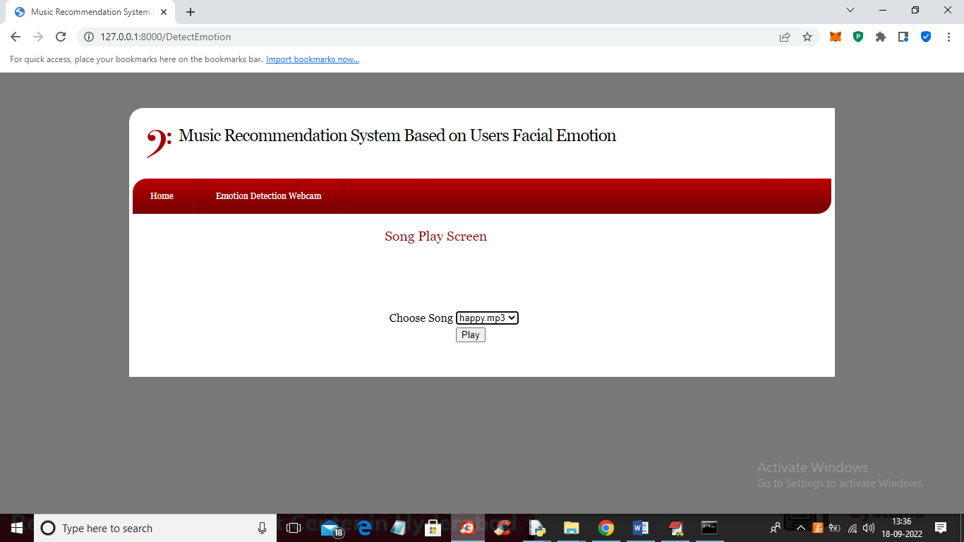

In above screen ‘Happy’ emotion detected and we got list of happy songs and user can select any song from drop down list and then click on ‘Play’ button to play song and while playing he can stop also. Now try another emotion

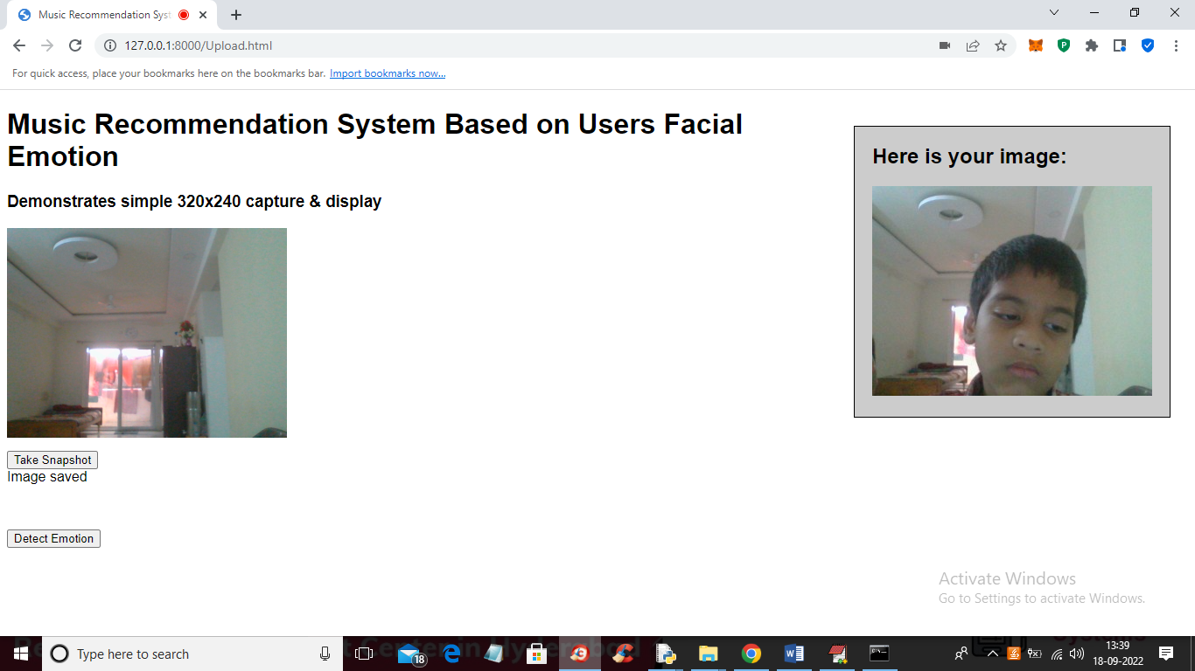

In above screen we captured another emotion face and now click on ‘Detect Emotion’ button to get below page

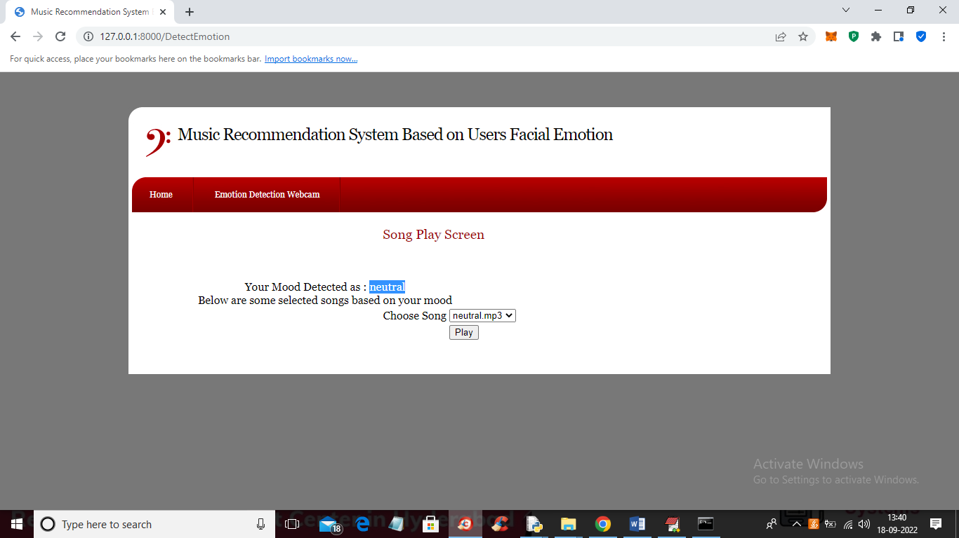

In above screen Neutral emotion detected and all neutral songs are displaying now click on ‘Play’ button to get below output

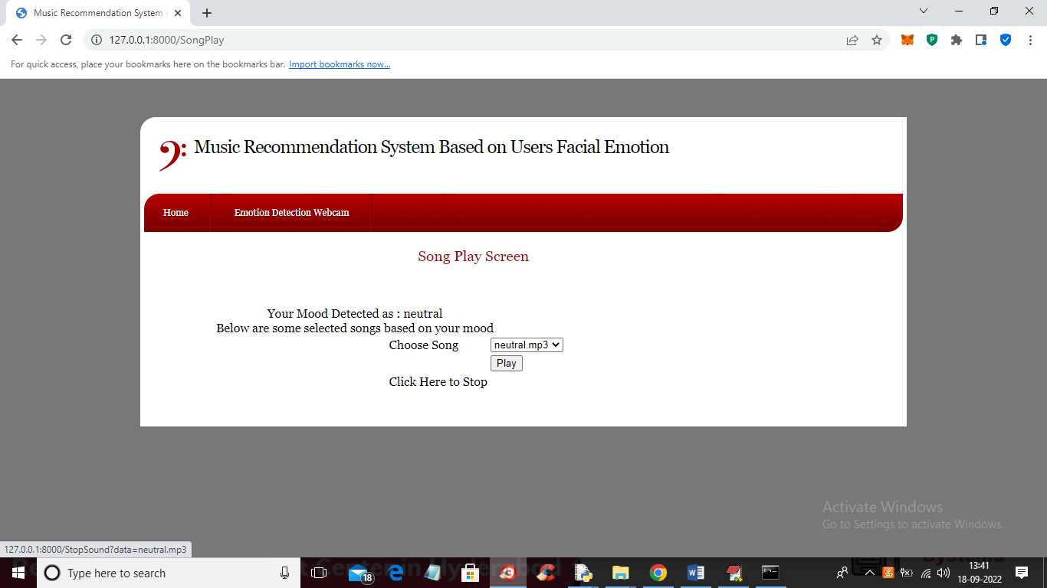

In above screen song will start playing and you can click on ‘Click Here to Stop’ link to stop play song.

Now in below screen we are trying another emotion

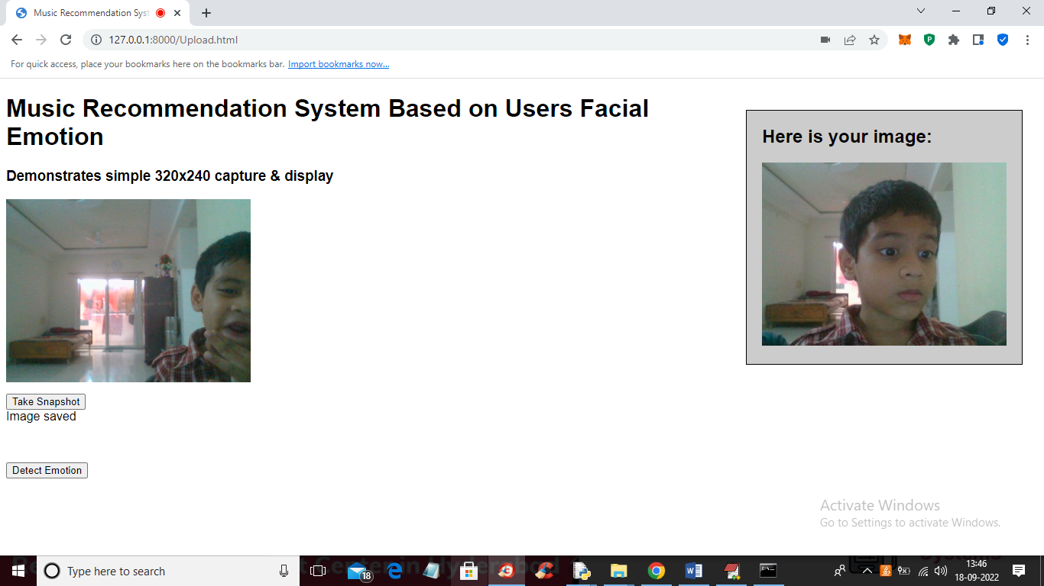

Now click on ‘Detect Emotion’ button to get below output

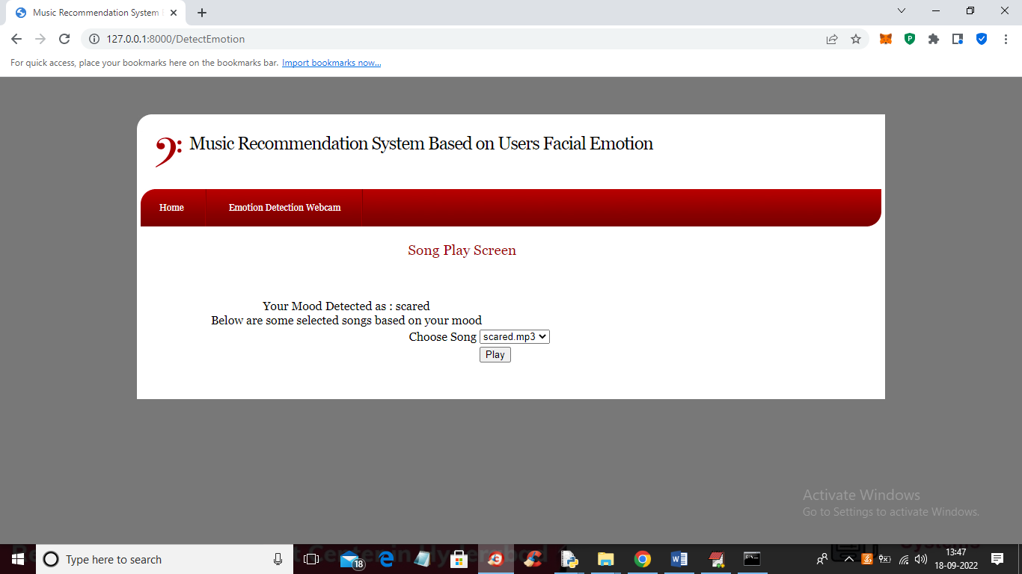

In above screen emotion detected as ‘Scared’ and similarly you can try various emotions and based on that emotion u will get songs list.

Note: in songs folder you can add new songs files also and application and algorithm is purely based on facial expression so try to show proper expression in Webcam to get proper emotion prediction